Data Structure and Algorithm

Laboratory Activity No. 5

Implementation of Arrays

|  |  |
| --- | --- |
| *Submitted by:* | *Instructor:* |
| LAPUT, MARK DANIELLE E. | Engr. Maria Rizette H. Sayo |
|  |  |

08, 29, 2025

# Objectives

Introduction

Array, in general, refers to an orderly arrangement of data elements. Array is a type of data structure that stores data elements in adjacent locations. Array is considered as linear data structure that stores elements of same data types. Hence, it is also called as a linear homogenous data structure.

This laboratory activity aims to implement the principles and techniques in:

* Writing algorithms using Array data structure
* Writing a python program that can implement Array data structure

# Methods

* Write a Python program to create an array of 10 integers and display the array items. Access individual elements through indexes and compute for the sum.
* Write a Python program to append a new item to the end of the array. Original array: numbers = [1, 2, 3, 4, 5, 6, 7, 8, 9, 10]
* Write a Python program to insert a new item before the second element in an existing array. Original array: numbers = [1, 2, 3, 4, 5, 6, 7, 8, 9, 10]
* Write a Python program to reverse the order of the items in the array. Original array: numbers = [5, 4, 3, 2, 1]

Write a Python program to get the length of the array. Original array: numbers = [5, 4, 3, 2, 1]

# Results

* + 1. 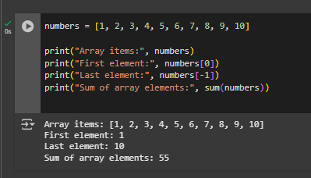

This program makes a list with 10 numbers from 1 to 10. It shows the first number, the last number, and then adds up all the numbers to get the total sum.

2. 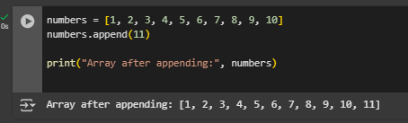

This program starts with a list of 10 numbers and then adds a new number at the end using the append() function. After adding, the list becomes longer with the new number included.

3. 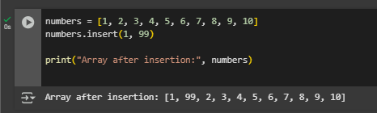

This program shows how to place a new number into the list at a chosen position. Here, the number 99 is added before the second number, so the list changes its order to include the new value.

4. 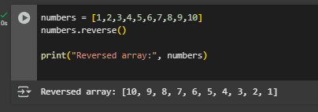

This program takes a list and flips it around so the numbers are shown in the opposite order. The first number becomes the last, and the last number becomes the first.

5. 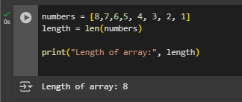

This program counts how many items are in the list by using the len() function. It is useful when we want to know the size of the list.

# Conclusion

These programs demonstrate some basic things we can do with arrays (lists) in Python. We learned how to create a list of numbers, select the first and last numbers, and sum all the numbers together. We also learned how to add a new number at the end, insert a number in the middle, reverse the list, and count how many numbers are in the list. By doing these exercises, we understand how lists function in Python and how to use them to store and modify data.

**References**

[1] [Python: Array - Exercises, Practice, Solution - w3resource](https://www.w3resource.com/python-exercises/array/)